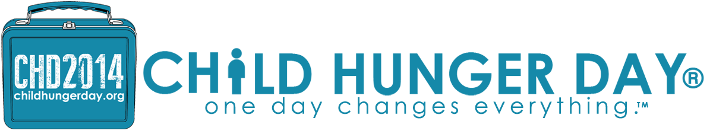
Child Hunger Day® Exists To Undo Hunger
CHILD HUNGER DAY® IS THURSDAY, NOVEMBER 13TH_ Chick-Fil-A will host 'SPIRIT NIGHT' @ Several Locations, from 5-8 pm & Portions of Proceeds will GO to Feeding Hungry Children in Middle Tennessee. Take The Child Hunger 365 Challenge®_ $1 A Day for The Next Year......
TAKE THE CHILD HUNGER 365 CHALLENGE®
Nov. 4, 2014 - NASHVILLE, Tenn. -- Child Hunger Day® is Thursday, November 13th, 2014. This day brings a new awareness to the child hunger epidemic, not only in America, but in Middle Tennessee. Several Nashville area Chick-Fil-A's are participating in Child Hunger Day® 'Spirit Night' from 5-8 pm, a portion of proceeds will go to undo hunger in Middle Tennessee.
Child Hunger Day® was created and organized by Burton Gaar, a long time successful fund raiser and non-profit innovator, who is on the front line, fighting for the right of every child to never go to bed hungry again.
Gaar says ,“Child Hunger Day® on November 13 and is an effort to bring awareness and increase funds to help undo hunger in Nashville and Middle Tennessee, by challenging good people to do great things”. His strategy is simple and effective.
The Child Hunger 365 Challenge® to help put an end to child hunger in our neighborhoods begins with just one dollar a day but can make a world of difference in the lives of untold millions of children.
Child Hunger Day® has rallied support from many local celebrities, entrepreneurs, politicians, and advocates, including Mike Hardwick, founder of Churchill Mortgage Company, and Candy Christmas, president and founder of The Bridge Ministry. Candy, along with her husband Kent, and their faithful team, have fed tens of thousands of homeless people every Tuesday night under the Jefferson street bridge in Nashville, TN since 2004.
A $1 A DAY DONATION CAN MAKE A DIFFERENCE
Mayors from the Greater Nashville area have thrown their support behind this worthy cause. Mayor Dean, who has been an outspoken advocate for the rights of children, has put his name and face behind this campaign to undo hunger in America and middle Tennessee. Other Mayors, like Mayor Hutto of Wilson County, have also gone on record in support of Child Hunger Day®, and took the time to send a clarion call to stop child hunger. You can watch CHD commercials, featuring pastors, business men and women, celebrities, children, community organizations, Christian biker associations, and others @ WWW.CHILDHUNGERDAY.ORG

NASHVILLE MAYOR KARL DEAN SUPPORTS CHILD HUNGER DAY®
http://youtu.be/f6k3H6_1c_A
"WIPE OUT" HUNGER IN AMERICA, NASHVILLE, AND MIDDLE TN.
Child Hunger can have significant long-term consequences. Children who are malnourished for even a brief period of time may experience irreversible cognitive and physical impairments. Proper nutrition is important in establishing and maintaining a good foundation that has implications on a child's future physical and mental health, academic achievement, and economic productivity.
Stats on Child Hunger: Tennessee ranks fourth in the nation at 17% of children suffering from hunger or lack of proper nutrition. This number represents White, African American, Native American, Latino, and Asian children across the entire state that never have enough food for three meals a day and most survive on one meal or less
Child Hunger also has economic consequences. The negative health outcomes of hunger that result in absenteeism and lower academic performance can result in a child being held back a grade or dropping out of school. These outcomes lead to a greater likelihood of limited employability, lessened workforce productivity, poorer judgment and poorer job performance.
We exist to bring awareness and increase funds to help undo child hunger in America by challenging good people to do great things and "Until we eradicate child hunger in America, every day is Child Hunger Day®". - Burton Gaar CEO/Creator
Child Hunger Day®_ November 13th_ 2014. For more information and how to donate now, go to www.childhungerday.org and take The Child Hunger 365 Challenge® to make a difference in lives of hungry children in America, and Middle Tennessee.
A3Marketing supports Child Hunger Day®.... Information within this article is created, compiled from other national hunger sources and organizations, the Child Hunger Day® website, and is edited to fit this format.

